You Found a Baby Skunk
Baby skunks can spray from birth! Their eyes open around 3 weeks. Seeing a single baby begs the question where is mom and siblings.
FIRST – Check the surroundings and look down and around. Do you see anything that might be a den? Under a porch? a deck? a shed?
EYES CLOSED BABIES can not regulate their own heat. Did mom get startled and drop it while moving her litter? With gloves put the baby in a secure container or box and provide a heat source. Rice in a sock warmed up or bottle of warm water. Never against their skin.
EYES – Are their eyes clear? They can get Canine Distemper https://iere.org/do-skunks-get-distemper/#google_vignette. A tiny bit of discharge may indicate dehydration, but a lot means something serious is going on.
FUR COLOUR – What colour is the white parts of fur? White - white? Yellowish? Yellow indicates dehydration.
FUR – Fleas? Ticks? Myiasis/Fly eggs? (eggs look like tiny grains of rice) Get every one off or it will hatch into a maggot.
GAIT – How are they walking around? Normal? Falling over? Going in circles?
If the baby’s eyes are open, have a cat carrier with a blanket or towel in it ready with the door open.
Bait with soft cat food or scrambled eggs in the carrier.
HOW TO PICK THEM UP – With gloves and moving in SLOW MOTION and WITHOUT TALKING…take one hand and gently scruff it behind the neck and at the same time with your other hand, tuck the tail under its bum quickly. Have another towel to cover the carrier. They are getting teeth and if they’re afraid, they will bite.
NO FOOD OR WATER unless you had to use it for bait. Soft scrambled eggs or softened puppy chow.
Call your nearest rehabilitator.
TRANSPORTING ANY WILD ANIMAL, we ask no radio and minimal talking.

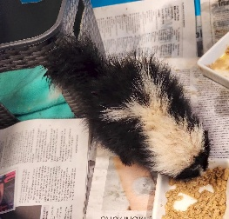
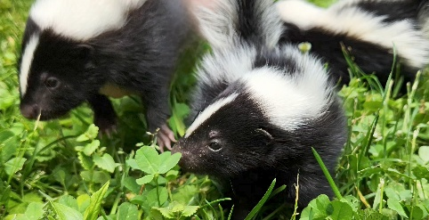

white fur – healthy yellow fur- orphaned or sick

You Found an Adult Skunk with a Can on its Head
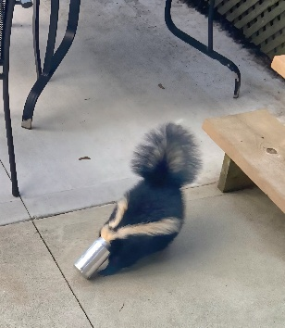
You can do this!! Best to have another person with you.
Get an old bath towel and soak it down with warm water.
ABSOLUTELY NO TALKING. You don’t want the skunk to know you are there. With gloves, approach the skunk from the back and quickly put the towel over him. HOLD THE TAIL DOWN. Remove the can or signal to your friend to gently twist it off.
Stand up slowly and retreat. Leave the towel over the skunk. He will wiggle out of it.
If the can won’t come off, call your local Animal Services or local rehabilitator.

